- Use COUNT() to count total orders.
select count(*) from orders;

output:
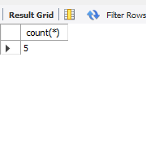
- Find the SUM() of all order prices.
select sum(price) from orders;

output:
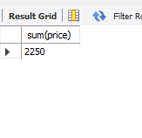
- Find the AVG() order price.
select avg(price) from orders;

output:
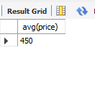
- Group orders by product_name and show total sales.
select product_name, sum(price) from orders group by product_name;

output:
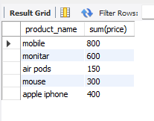
- Find the MAX() and MIN() price of orders.
select max(price), min(price) from orders;

output:
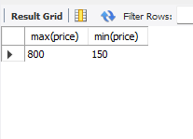
- Sort the grouped data by total sales descending.
select product_name, sum(price) as total_sales from orders group by(product_name) order by total_sales desc;

output:
